*MUSIC RECOMMENDATION SYSTEM*

***Abstract*—** **The intersection of music and mental health is a field that has been gaining a lot of popularity and credit, with research increasingly suggesting beneficial effects of the use of music as an intervention for several emotional states. This paper investigates the development of a user model for music recommendations as introduced by machine learning which aims at adapting genre suggestions according to mental health needs. We used a data set from Kaggle to conduct this study in the form of mental health diagnosis information, and musical preferences across genres. These results demonstrate that our model is capable of recommending music genres according to the emotional and psychological profiles, enhancing a personalized experience in content consumption. It could be built into music streaming services where it serves as an emotional therapeutic tool for users, to increase their well-being through music.**

Keywords— Music and Mental Health, Music Intervention, Music Recommendation System, Genre Suggestions, Emotional Therapeutic Tool

Introduction

Music is known to be effective at handling mental health issues because it can also alter emotions and human behaviour. In this digital era, with music libraries of unimaginable size at our fingertips, we need networks to give personalized suggestions for emotional states or mental health; However, existing recommendation engines are primarily reliant upon the behavioural or listening activities of users and do not take psychological aspects into account to assess an individual's musical preferences, leading to potential negative public health outcomes.

This motivated us to work on a project towards developing a genre recommendation system that is mental health specific. A music recommendation system built on machine learning algorithms.

Initially, as our project's basic foundations were being laid we fetched the dataset from Kaggle through which we got access to a big dataset containing information such as user age range and mental health conditions with their music preferences. We conducted exploratory data analysis (EDA) to understand the relationships between these variables.

With the knowledge gained, we have employed multiple machine learning models like Logistic Regression, Decision Tree and Random Forests to create our recommendation system. The results of our study demonstrate the system's ability to provide targeted music recommendations, offering users a personalized and emotionally supportive tool that enhances their mental well-being.

# **ADVANCEMENTS IN THE FIELD**

## **The Impact of Music Therapy on Anxiety in Cancer Patients Undergoing Simulation for Radiation Therapy**

Radiation therapy when recommended to people who are affected by cancer often hold a lot of fear against the process. However, the first step towards treatment is always how it is going to be perceived throughout the duration. Anxiety is not unusual before undergoing treatment with significantly concerning levels going on deaf ears. Most of the anxiety induced during the RT is due to the restrain on body movements applied along with isolation in an unfamiliar place. Before conducting the music therapy session, the patients were asked to complete pre-State Trait Anxiety Inventory questionnaire, Likert type scale, the Symptom Distress Thermometer (SDT) to get knowledge on what the patient was feeling at the moment instead of in the past week. According to the data obtained during the assessments conducted, individual pieces of music were connected in a sequence that moved progressively from pieces with higher levels of activating qualities to pieces with higher levels of relaxing qualities to reduce anxiety.

The findings depicted a strong reduction in high states of anxiety for the MT cohort while the anxiety levels fairly increased for the non-MT cohort. During the RT of patients, “subclinical” levels of distress is very common in cancer patients, and can cause session disruptions as well as emotional damage. This is even more prevalent in patients undergoing chemotherapy for neck and brain cancers. We have seen that music therapy showed good levels of clinical efficacy for patients with higher levels of anxiety and the reduction in these levels led to them coming down to “subclinical” values. whatever reduction in the levels of distress contributes to a better patient experience leading to better tolerance of high level of pain and discomfort. This makes us believe music therapy is extremely effective in addressing emotional domain of distress and anxiety caused by Radiation therapy during cancer treatment.

## **A Systematic Review of Scientific Studies and Case Reports on Music and Obsessive-Compulsive Disorder**

OCD involves having of intrusive thoughts, images or impulses, which compel the patient to perform compulsive behaviours with an aim of minimizing the worry and fear. Cognitive flexibility is one of the areas that are impaired in patients with OCD across different cultures and affects their quality of life tremendously.

Patients are treated using medications along with psychological therapies. The treatments that are most often employed are Selective Serotonin Reuptake inhibitors (SSRIs) and cognitive behavioral therapy (CBT). Nevertheless, these treatments show differences in their outcomes and other modes of therapy might be needed.

Some previous works have shown that accepting and improvisational music therapy has reduced the obsessive and compulsive signs. Relaxing music, sleep music, and meditation music are ways through which OCD patients have been relieved of symptoms because the strategies lower the degree of the symptoms experienced.

It also has been indicated to lessen depressive and anxious symptoms in clients diagnosed with OCD. Receptive music therapy when supplemented with improvisational music therapy was seen to have a greater resocializing effect than simple receptive music therapy. This highlights the role of a positive association since people with OCD traits are more emotionally responsive to music therefore indicating that OCD may be associated with music based interventions.In general, music therapy might act as one of the additional treatments that may be helpful in reducing OCD manifestations and enhancing the quality of life of patients with this condition.

## **The effectiveness of music therapy on sleep quality and insomnia in middle-aged people**

It is still common to hear insomnia being treated through drug based methods. However, sleeping medication causes drug dependence or drug tolerance once one begins taking for long time. Modern researches in this field have revealed that the use of sleeping tablets during clinical practice actually does not have a positive effect on the quality of sleep. Therefore, effective interventions for managing sleep problems using non-pharmacological approaches is a crucial question nowadays. Relaxing music causes a relaxing effect, elicits responses, decreases activity in the neuroendocrine and sympathetic nervous systems, and in turn decreases anxiety, frequency of breaths per minute, and systolic blood pressure. Music decreases the quantity of noradrenaline present and this hormone is associated with sleep beginning. Hypothetically, meaningful and goal-oriented music intervention during the day and before going to bed contributes to increasing night sleep and daily energy, and the joint use of the two methods enhances the quality of sleep and decreases the level of insomnia. Since music can have a profound impact on such important aspects of life, including psychological and motor states, mood, and sleep, the present study was designed solely to explore the impact of music therapy on sleep quality and insomnia in middle-aged persons. The selected persons were then equally divided using simple random sampling into the intervention and control groups. The inclusion criteria were being of age 50 to 60, with sleep problems, no existing use of drugs, pain relievers, antidepressants, sleeping pills, alcohol; willingness to participate in the study; an ISI score above 14 out of 28; and a PSQI score of between 6 and 21. The outcome presented showed that music therapy has a positive influence on the quality of sleep of middle-aged populations.

Identify applicable funding agency here. If none, delete this text box.

# **DEVELOPING OF THE MODEL**

## **About The Dataset**

## This paper outlines the process of training a machine learning model designed to recommend music genres tailored to various mental health conditions. We acquired the dataset from Kaggle, an established and reputable data source known for providing reliable and trustworthy datasets which gave as a good foundation for our project.

## The original dataset is composed of 736 rows and 32 columns. We converted the categorical data in our model into a numerical format, assigning 0 for false and 1 for true. This conversion was necessary to be able to run the machine learning processes. Next, we used one-hot encoding to convert the data into 47 columns so that each unique category is represented in a fashion which can be understood by machine learning algorithms.

## Decision trees and random forest algorithms were applied for model building. This is primarily because these techniques are able to handle multidimensional data and can be collectively seen as one of the best suited ones with their capability in building more accurate models which will tend toward less overfitting. Therefore, our music recommendation system adopts such a method in order to provide personalized and efficient musical recommendations for enhancing mental health.

## **Insights about the dataset**

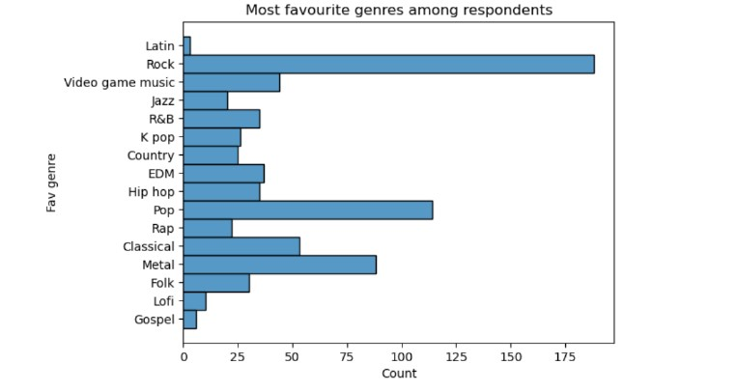

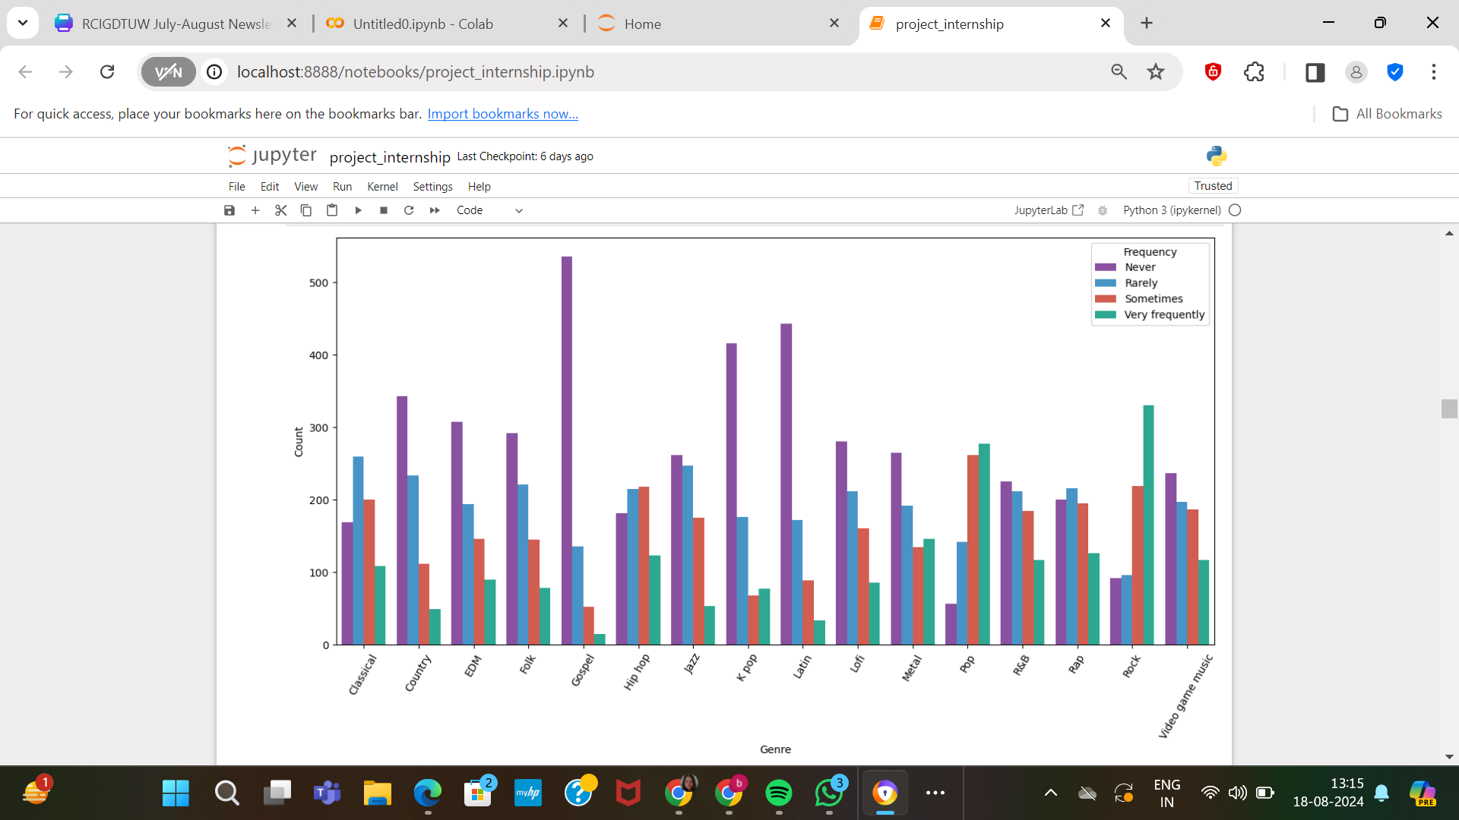

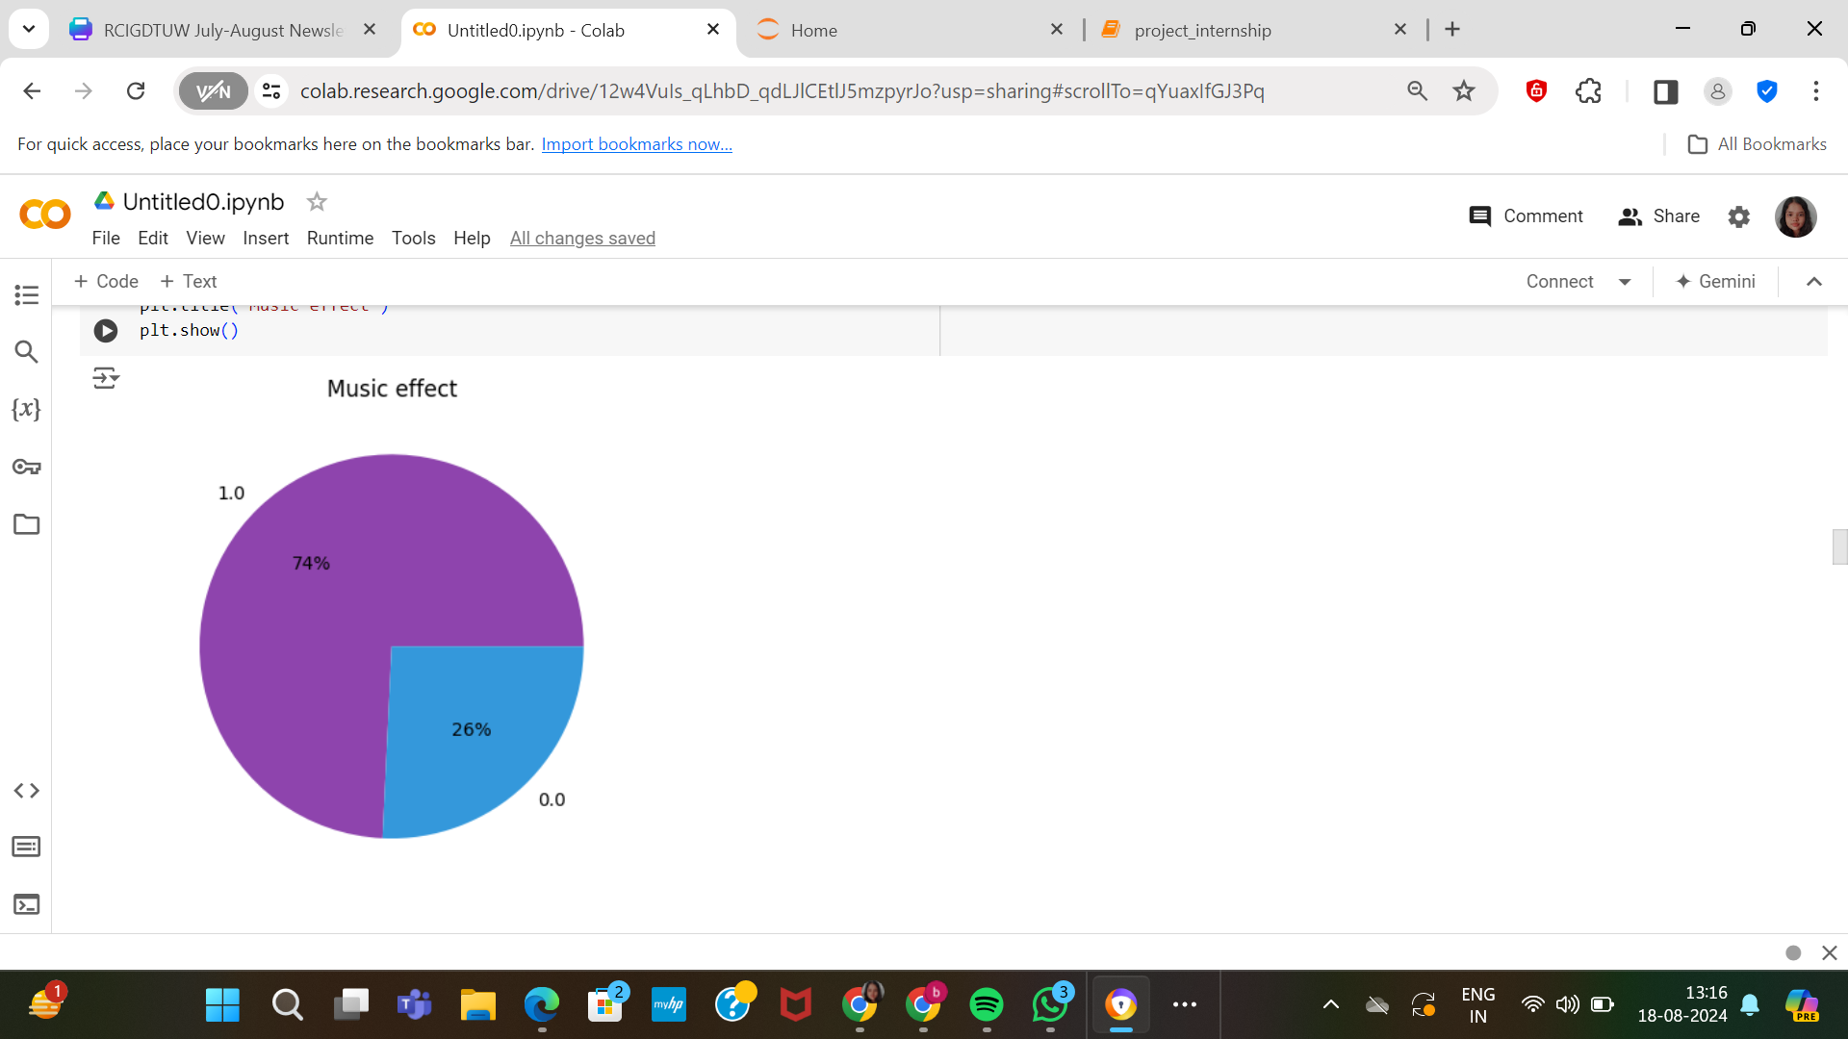

***# Note: 1.0 represents improvement in the mental health condition. 0.0 represents no effect or effects being worsened***

## **Python libraries used**

* **Pandas** - For data manipulation and organization of dataset containing information regarding favourite genres of people experiencing varied mental health issues
* **NumPy**- For handling numerical data and calculations
* **Seaborn –** Was employed to visualize the correlations between various columns in the dataset.
* **Matplotlib -** Matplotlib was imported to enhance the visualization capabilities of our model. It allowed us to create a variety of plots and charts, which facilitated the exploration and understanding of the dataset.
* **train_test_split from sklearn.model_selection library-** Was employed to split the dataset into training and testing data
* **LogisticRegression from sklearn. linear_model-** To train the model using Logistic regression
* **classification_report from sklearn. metrics** – was employed to generate a text report showing the main classification metrics such as precision, recall, f1-score
* **accuracy_score from sklearn.metrics-** for computing the accuracy of the model trained, which is the ratio of correctly predicted observations to the total observations.
* **DecisionTreeClassifier from sklearn.tree-** was employed for the creation of a decision tree structure where the data is split based on feature values to make predictions. This method is particularly useful for understanding the importance of different features and for visualizing the decision-making process of the model.



# **IMPLEMENTATION OF THE MODEL**

## **Installation and importing Python packages-**

Various inbuilt python libraries have been used in the implementation of the model. The various libraries used for the training of this model are as follows:

a) *Pandas*

*b) NumPy*

*c) Matplotlib*

*d) Seaborn*

*e) Sci-kit learn* (various functions of sci-kit learn were used extensively throughout the training of this model)

## **Loading the dataset into the computing platform and one-hot encoding the dataset**

## The dataset was loaded into the computing environment following which it was pre-processed and cleaned for training the model using Random forest and Decision trees. For the pre-processing of data, one-hot encoding method was leveraged. One-hot encoding is a process of converting categorical data into numerical data. The main motive behind this step was to facilitate:

## a) Creation of independent binary features: It transforms each category into an independent binary value, allowing the model to then assess whether a given piece of data belongs to one or another. This gives an honest representation of the data and is especially great when you are using algorithms such as logistic regression because they very much depend on linear combinations between input features.

## b) Streamline the processing of categorical data: Logistic regression and decision trees are algorithms that require numerical input, hence one-hot encoding was deployed.

## **3.** **Exploratory Data Analysis**

##### In this step the correlations between various columns of the dataset were visualised using matplotlib and seaborn. The visualisation of the dataset using pie charts, bar graphs helped us better understand and pinpoint connections among the various columns.

## **Assigning columns to X and Y and selecting the target variable**

4.1) *Defining the Target Variable*: The target data shows the impact different genres of music had on the participants and is stored in a column 'Music effects' (Typically shown as y).

4.2) *Feature Selection:* The code selects columns in the data frame with a name containing 'Fav genre_', i.e. these are favorite genres of music - one-hot-encoded features. These columns are saved in the variable one_hot_encoded_genres_columns.

4.3) *Feature Matrix Construction*: The feature matrix X is constructed by combining several specific columns: 'Anxiety', 'Depression', 'Insomnia', and 'OCD', along with the one-hot encoded genre columns. This results in a comprehensive set of features that includes both psychological metrics and music genre preferences.

4.4) *Data splitting*: the ‘train_test_split’ function is used to divide the dataset into training and testing data, where 20% of the dataset is allocated to the test set, while the remaining 80% is used for training the model.

1. ***Evaluating the effectiveness of various classifiers***

*In this step multiple classifiers are tested and their performances are assessed to ascertain the best method to train the ML model*

5.1) *To handle Missing Values*- *y_train = np. nan_to_num(y_train)*: This will replace every NaN value in the dataset with real values which are typically zero. This is necessary to avoid any disruptions in the training process due to missing values.

5.2) *Importing metrics and Classifier Initialization*- The confusion_matrix and ConfusionMatrixDisplay function from sklearn is deployed to evaluate and plot classifier performance. A dictionary is created with name classifiers which has all these machine learning model: Logistic Regression, Decision Tree, Random Forest, Support Vector Machine (SVM), K-Nearest Neighbors (KNN). Each model is instantiated with default parameters or basic configurations.

5.3) *Training the model and evaluating its efficiency*- A loop iterates over each element of the classifier dictionary

- **Training:** *clf. fit (X_train, y_train)* is for training the current classifier with the training data (*X_train and y_train*).

- **Prediction:** *y_pred = clf. predict(X_test)* uses the trained model to make predictions on test set X_test.

- **Confusion Matrix*:*** *cm = confusion_matrix (y_test, y_pred)* computes the confusion matrix for the given classifier. This matrix illustrates the accuracy of our model's predictions in relation to the actual class labels.

-**Cataloging Results:** The corresponding accuracy score is stored in the results dictionary with the classifier name as key.

5.4*) Output Formatting*: The accuracy score is displayed as a percentage with 2 decimal points for each classifier

*In a nutshell, this step deals with training and evaluating all classifiers on the same dataset to get an idea which one is most effective for a given case with accuracy and other parameters.*

1. ***Training the model using Logistic Regression and optimizing it using hyperparameter tuning***

We used the two algorithms of Logistic Regression and Decision Tree to train and test the model to establish which of the two had a higher accuracy. First, the use of logistic regression was employed to train the model, after which, the ensemble of Logistic Regression model was achieved through hyperparameter tuning.

To do so, we employed the GridSearchCV function from sklearn for constructing the dynamics of the model. 'model selection' was deployed to allow for a more exhaustive testing of various hyperparameters in order to determine the best parameters to use. Thus, our parameter grid was, *C* for controlling the strength of the regularizations, *penalty* for the type of regularization*, solver* for the type of solver to use and *max_iter* that determined the number of iterations

1. ***Training the model using decision trees and optimizing it using Random Forest and hyperparameter tuning***

The machine learning workflow started with the training of a Decision Tree model, one of the simplest and strongest algorithms to solve classification problems. Finally, we used hyperparameter tuning to adjust the behavior of our model in order to optimize its performance. In our case, we used the GridSearchCV library to precisely scan through different hyperparameters configurations and find out which one works best. Having found the optimal parameters for our Decision Tree, we advanced to an algorithm which improves upon its predictive power: Random Forest. Switching to Random Forest, which facilitated in achieving a precision of 82.74% and 77.70% accuracy. We created a confusion matrix which was very useful in understanding the model performance across different classes. This matrix allowed us to analyze the distribution of true positives, true negatives, false positives, and false negatives, offering a comprehensive overview

# **CHALLENGES WHILE MAKING THE MODEL**

*The rationale for the comparatively low accuracy of the model, even after optimization:*

1) *Data Quality*: The dataset relies on self-diagnosed responses, which could lead to inconsistencies, inaccuracies, or biases, affecting the reliability of the model.

2) *Categorical Data Conversion*: Converting categorical data into numerical form led to loss of some data.

3) *Interpreting Mental Health Data*: Mental health data is often subjective and complex, making it difficult to accurately quantify and model the impact of certain factors on music preferences.

4) *Handling Missing Data*: Dealing with missing or incomplete data was perplexing.

5) *User Bias*: Users' self-reported data might be biased by their mood at the time of the survey, or by societal factors, affecting the accuracy of the model's recommendations.

# **Conclusion**

This research paper provides a vast development and implementation overview for a music recommendation system, by the use of machine learning, to cater to different kinds of mental health disorders. Considering the technical challenges that are being tackled, taking leverage from recent advancements, and considering broader impacts of personalized music therapy, it is a great contribution to the growing intersection of technology in mental health care. The AI model proposed in this work is able to show an extended capability in the recommendation of music genres based on certain mental health issues, using a dataset that has been pre-processed and fine-tuned with an aim for optimal performance. Furthermore, this architecture design can be effortlessly expanded with others machine learning approaches to provide a global manner on music recommendation for mental health. This system offers individualized music recommended genres, addressed to specific mental health condition that the subjects are experiencing and therefore prove to be valid in support of therapeutic intervention within mental health. This holistic actionable pathway thereby boosts the machine learning embedded with music therapy in a powerful way, and hence has illuminated better directions for upcoming researches as well as practically more beneficial implementations towards reinforced personalized mental health care recommendations fire.

##### **ACKNOWLEDGEMENTS**

We extend our sincere gratitude to all those who contributed to the successful completion of this research endeavor. This work would not have been possible without the collective effort, support, and inspiration provided by numerous individuals.

First and foremost, we would like to extend our heartfelt gratitude to Indira Gandhi Delhi Technical University for Women (IGDTUW) for providing us with the incredible opportunity to participate in the insightful internship program on Python and Machine Learning. The knowledge and skills we have gained through this program have been invaluable, and we are deeply thankful for the chance to apply them in a hands-on project. The university's commitment to fostering an environment of learning and innovation has been instrumental in our academic and professional growth, and we are truly grateful for the support and encouragement we have received every step of the way.

##### We would also like to express our sincere appreciation to our mentor, Ms. Nidhi Grover Raheja, for her exceptional guidance and dedication throughout this journey. Her deep knowledge of Python and Machine Learning, coupled with her patient teaching style, made complex concepts accessible and understandable. The insights and expertise she shared were instrumental in the successful construction of this project. We are immensely grateful for her unwavering support, which has not only enriched our understanding but also inspired us to push the boundaries of our learning.

##### **References**

The template will number citations consecutively within brackets [1]. The sentence punctuation follows the bracket [2]. Refer simply to the reference number, as in [3]—do not use “Ref. [3]” or “reference [3]” except at the beginning of a sentence: “Reference [3] was the first ...”

Number footnotes separately in superscripts. Place the actual footnote at the bottom of the column in which it was cited. Do not put footnotes in the abstract or reference list. Use letters for table footnotes.

Unless there are six authors or more give all authors’ names; do not use “et al.”. Papers that have not been published, even if they have been submitted for publication, should be cited as “unpublished” [4]. Papers that have been accepted for publication should be cited as “in press” [5]. Capitalize only the first word in a paper title, except for proper nouns and element symbols.

For papers published in translation journals, please give the English citation first, followed by the original foreign-language citation [6].

1. G. Eason, B. Noble, and I. N. Sneddon, “On certain integrals of Lipschitz-Hankel type involving products of Bessel functions,” Phil. Trans. Roy. Soc. London, vol. A247, pp. 529–551, April 1955. *(references)*
2. J. Clerk Maxwell, A Treatise on Electricity and Magnetism, 3rd ed., vol. 2. Oxford: Clarendon, 1892, pp.68–73.
3. I. S. Jacobs and C. P. Bean, “Fine particles, thin films and exchange anisotropy,” in Magnetism, vol. III, G. T. Rado and H. Suhl, Eds. New York: Academic, 1963, pp. 271–350.
4. K. Elissa, “Title of paper if known,” unpublished.
5. R. Nicole, “Title of paper with only first word capitalized,” J. Name Stand. Abbrev., in press.
6. Y. Yorozu, M. Hirano, K. Oka, and Y. Tagawa, “Electron spectroscopy studies on magneto-optical media and plastic substrate interface,” IEEE Transl. J. Magn. Japan, vol. 2, pp. 740–741, August 1987 [Digests 9th Annual Conf. Magnetics Japan, p. 301, 1982].
7. M. Young, The Technical Writer’s Handbook. Mill Valley, CA: University Science, 1989.
8. K. Eves and J. Valasek, “Adaptive control for singularly perturbed systems examples,” Code Ocean, Aug. 2023. [Online]. Available: <https://codeocean.com/capsule/4989235/tree>
9. D. P. Kingma and M. Welling, “Auto-encoding variational Bayes,” 2013, arXiv:1312.6114. [Online]. Available: <https://arxiv.org/abs/1312.6114>
10. S. Liu, “Wi-Fi Energy Detection Testbed (12MTC),” 2023, gitHub repository. [Online]. Available: https://github.com/liustone99/Wi-Fi-Energy-Detection-Testbed-12MTC
11. “Treatment episode data set: discharges (TEDS-D): concatenated, 2006 to 2009.” U.S. Department of Health and Human Services, Substance Abuse and Mental Health Services Administration, Office of Applied Studies, August, 2013, DOI:10.3886/ICPSR30122.v2

**IEEE conference templates contain guidance text for composing and formatting conference papers. Please ensure that all template text is removed from your conference paper prior to submission to the conference. Failure to remove template text from your paper may result in your paper not being published.**